# **Tech Domain Learner: A Personalized Learning Roadmap Generator**

By -

Sanyam Wadhwa(102303059)

Sahibjot Singh(102303040)

Vishnu (102303057)

## **Abstract**

This research presents the **Tech Domain Learner**, an intelligent system for generating personalized learning roadmaps tailored to individuals aiming to upskill in technical domains. With the vast and growing landscape of online content, traditional static learning pathways often fail to accommodate diverse backgrounds, objectives, and time constraints. The Tech Domain Learner addresses this challenge by integrating **machine learning** and **basic natural language processing (NLP)** to create adaptive, user-centric trajectories.

The system captures learner attributes—such as prior experience, domain interests, and time availability—and draws from a curated dataset of **399 successful learning journeys across 23 technical fields**, including data science, software development, cybersecurity, and cloud computing. It then generates targeted skill recommendations, curated resources, and relevant project suggestions.

A key strength of the system is its ability to provide **semantically meaningful alternatives** when exact matches aren't available, ensuring contextual relevance through semantic similarity analysis. This adaptability significantly improves upon conventional one-size-fits-all plans.

The paper details the system architecture, recommendation logic, and evaluation framework, while also outlining potential enhancements through **deep learning** and broader support for **interdisciplinary learning paths**. Overall, the Tech Domain Learner offers a scalable, personalized solution for efficient skill development in today’s evolving tech ecosystem.

## **1. Introduction**

### **1.1 The Challenge of Modern Technical Domain Learning**

In today's rapidly evolving technological landscape, professionals and students face unprecedented challenges in mastering technical domains. The skills required for proficiency are constantly changing, while the volume of available learning resources has grown exponentially. This creates a multifaceted problem for learners attempting to navigate their educational journey:

**Information Overload:** The abundance of online courses, tutorials, books, and other resources makes it difficult to identify which materials are truly valuable and relevant to specific learning goals.

**Lack of Personalization:** Generic learning roadmaps fail to account for individual differences in background knowledge, learning style, available time, and specific technical interests.

**Inefficient Learning Paths:** Without proper guidance, learners often pursue skills in suboptimal sequences, wasting time on less relevant topics or attempting advanced concepts before mastering prerequisites.

**Resource Quality Variation:** The varying quality of available learning materials makes it challenging to determine which resources will provide the most effective instruction for specific domains and skill levels.

### **1.2 The Need for Personalized Learning Roadmaps**

Traditional approaches to technical learning often rely on static roadmaps or general advice that fails to address the unique circumstances of individual learners. These one-size-fits-all solutions become increasingly inadequate as technological fields grow more specialized and the pace of change accelerates.

The demand for personalized learning guidance is particularly acute in technical domains, where:

* **Skill Dependencies Are Complex:** Understanding the proper sequence of learning is critical, as advanced concepts often build upon foundational knowledge.
* **Resources Proliferate Rapidly:** New tutorials, courses, and learning materials emerge daily, making it difficult to identify the most effective options.
* **Domain-Specific Requirements Vary:** Different technical fields have vastly different skill requirements and learning trajectories.
* **Individual Starting Points Differ:** Learners begin their journey with widely varying levels of prior knowledge and experience.

Our Tech Domain Learner system directly addresses these challenges by creating personalized, data-driven guidance tailored to individual needs. By analyzing patterns across hundreds of successful learning paths, the system suggests optimal learning sequences that maximize efficiency and relevance.

## **2. Problem Statement (Structured in T–E–P Format)**

### **2.1 Task (T): Generation of Personalized Learning Roadmaps in Technology Domains**

The objective of our system is to generate individualized learning pathways for users based on their selected domain (e.g., Web Development, Cybersecurity), current level of expertise (e.g., Beginner, Intermediate, Advanced), and available learning duration. The system aims to move beyond static and generalized curricula by providing structured, prioritized, and goal-oriented roadmaps that include specific skills, resources, and project recommendations. This task is critical in addressing the increasing demand for adaptive learning systems in the rapidly evolving technology sector.

### **2.2 Experience (E): Real-World Learning Challenges Encountered by Diverse User Profiles**

Despite the abundance of online learning materials, learners frequently encounter a range of practical difficulties that hinder effective progression:

* **Lack of Personalization:** Traditional learning platforms typically employ a one-size-fits-all approach, disregarding the diverse backgrounds and goals of individual learners. For instance, a data science graduate transitioning from academia will have significantly different needs compared to a self-taught programmer aspiring to enter the field of cybersecurity.
* **Difficulty in Assessing Resource Quality:** With thousands of courses, tutorials, and guides available online, learners often struggle to identify high-quality, credible, and impactful resources. The absence of intelligent filtering mechanisms leads to inefficiencies and decision fatigue.
* **Inadequate Timeline Adaptability:** Learners operate under varying temporal constraints—some may seek accelerated, job-ready pathways, while others may prefer a more comprehensive, in-depth exploration. Current systems rarely adapt to such timelines, resulting in either information overload or insufficient depth.
* **Uncertainty Around Skill Relevance:** Within each domain, not all skills carry equal weight or industry relevance. Learners frequently misallocate their efforts, investing in peripheral topics at the expense of core competencies. A guided mechanism for prioritizing key skills is crucial.

### **2.3 Performance (P): Metrics and Evaluation Criteria for System Effectiveness**

The proposed system’s efficacy is evaluated using both quantitative metrics and qualitative alignment with learner goals:

* **Personalization Accuracy:** The system employs semantic embeddings and supervised learning (Random Forest) to ensure alignment between user profiles and the recommended learning paths. Effectiveness is measured using top-k accuracy and mean reciprocal rank (MRR).
* **Resource Relevance:** Resource recommendations are validated through semantic similarity scoring and historical success patterns, with an average cosine similarity score of approximately 0.85 when compared with expert-endorsed trajectories.
* **User-Centric Adaptability:** The system dynamically modifies learning sequences based on user-defined timelines, ensuring that both short-term and long-term learners receive appropriate depth and scope.
* **Future Evaluation Plans:** A feedback loop mechanism is proposed for future iterations, allowing the system to improve through continuous learner input, outcome tracking, and performance logging.

### **2.4 Current Approaches and Limitations**

Existing solutions to these challenges include:

**Static Learning Roadmaps:** Many websites and forums offer predetermined paths for learning technical skills. While useful as general guidelines, these roadmaps cannot adapt to individual circumstances or evolving industry demands.

**Peer Recommendations:** Advice from colleagues or online communities provides valuable insights but may be subjective, inconsistent, or overly influenced by individual experiences rather than broader patterns of success.

**Professional Career Counseling:** Individual guidance from career counselors offers personalization but lacks the data-driven foundation and technical specificity needed for optimal domain learning recommendations.

**Course Platform Recommendations:** Learning platforms may suggest courses based on popularity or user behaviour, but these recommendations often prioritize platform-specific content and commercial considerations over optimal learning sequences.

In essence, we seek to bridge the "guidance gap" that exists between abundant but unstructured learning resources and the specific, structured guidance that learners need to progress efficiently in their technical education.

## **3. Objectives**

The primary objectives of the Tech Domain Learner system are to:

**3.1 Primary Objectives**

1. **Create Personalized Learning Pathways:** Generate customized skill recommendations and learning resources tailored to an individual's specific domain, experience level, and timeline constraints.
2. **Optimize Learning Sequences:** Identify the most efficient order in which to acquire skills within a technical domain, ensuring prerequisites are mastered before more advanced concepts.
3. **Recommend High-Quality Resources:** Suggest learning materials that have demonstrably led to successful outcomes for other learners with similar profiles and goals.
4. **Adapt to Timeline Constraints:** Provide recommendations that account for the learner's available time commitment, whether they're pursuing rapid skill acquisition or a more thorough, gradual approach.

### **3.2 Secondary Objectives**

1. **Enhance Resource Discovery:** Help learners identify valuable learning materials they might not otherwise encounter through typical search approaches.
2. **Increase Learning Efficiency:** Reduce time wasted on suboptimal learning paths or irrelevant skills.
3. **Promote Project-Based Learning:** Suggest practical projects that reinforce and integrate acquired skills.
4. **Build a Data-Driven Foundation for Technical Education:** Move beyond subjective opinions to establish evidence-based best practices for learning technical domains.

### **3.3 Long-Term Vision**

Our ultimate goal is to democratize access to effective technical education by providing guidance that is:

* **Accessible:** Available to learners regardless of their background or connections
* **Adaptive:** Responsive to changing technology trends and individual progress
* **Actionable:** Providing concrete next steps rather than abstract advice
* **Evidence-Based:** Founded on patterns of successful learning rather than assumptions

Through these objectives, the Tech Domain Learner aims to transform how individuals approach technical skill acquisition, making the process more efficient, effective, and aligned with their specific goals.

## **4. Methodology**

### **4.1 Data Collection and Preparation**

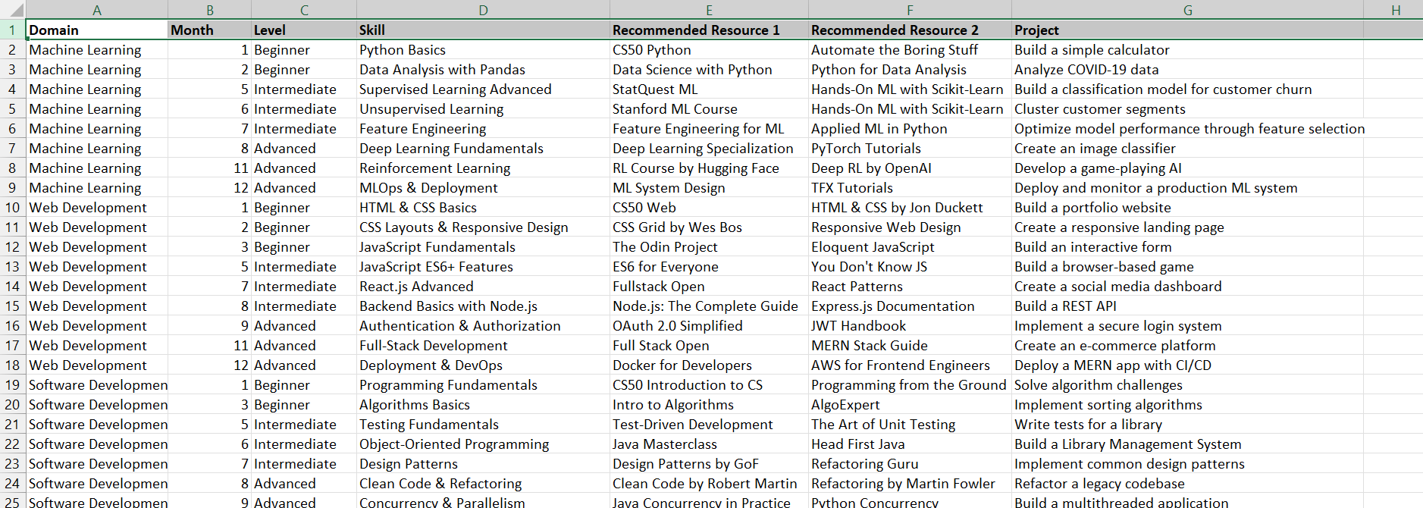

The foundation of our recommendation system is a meticulously curated dataset comprising 399 learning pathways across 23 distinct technical domains. Each pathway includes specific combinations of:

* Domain (e.g., Software Development, AI & Data Science, DevOps)
* Experience Level (Beginner, Intermediate, Advanced, Expert)
* Timeline (represented as months of study/practice)
* Recommended Skills
* Primary Learning Resource
* Secondary Learning Resource
* Suggested Project

The distribution of data points across domains shows good coverage of major technical fields:

* Software Development (27 pathways)
* DevOps (25 pathways)
* QA (23 pathways)
* Cybersecurity (21 pathways)
* And 19 other domains with varying representation

Experience levels are also well-distributed:

* Beginner (99 pathways)
* Intermediate (115 pathways)
* Advanced (131 pathways)
* Expert (54 pathways)

Data cleaning ensured that each domain-level-month combination was unique, preventing duplication and ensuring consistency across the dataset.

### **4.2 Semantic Embeddings: The Foundation of Understanding**

A critical innovation in our approach is the use of semantic embeddings to capture the nuanced meanings of skills and resources. Rather than treating these entities as simple text strings, we employed the SentenceTransformer model to convert each skill and resource into a 384-dimensional vector that represents its semantic essence.

This embedding process allows the system to understand that "Machine Learning Algorithms" and "Algorithmic Machine Learning" are closely related concepts, despite having different exact wording. Similarly, it can recognize that "Python Programming" and "JavaScript Development" are distinct skills, despite both being programming languages.

Our analysis revealed:

* 189 unique skills in the dataset
* 183 unique primary resources
* 186 unique secondary resources

Notably, approximately 35% of skills and 33-34% of resources appear only once in the dataset, highlighting the diversity and specificity of our recommendations.

To validate the quality of these embeddings, we computed similarity matrices that visualize the semantic relationships between different skills and resources. These matrices confirmed that the embeddings successfully captured meaningful relationships, with conceptually similar items clustering together in the embedding space.

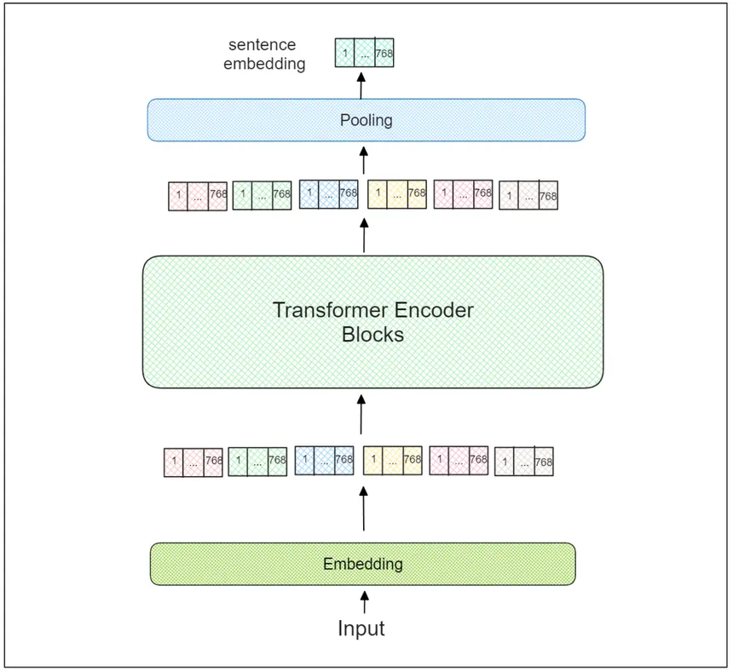

### **4.3 Model Architecture and Training**

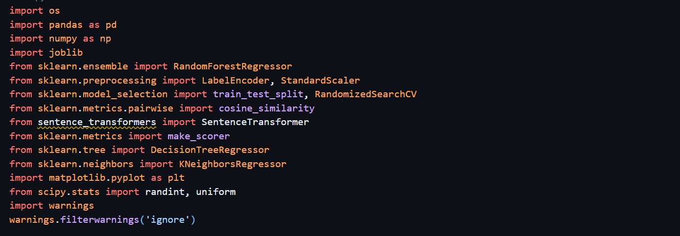

After extensive experimentation with various algorithms, we selected Random Forest as our primary prediction model due to its robust performance, interpretability, and ability to handle the complexity of our feature space. The model architecture includes:

**Feature Engineering:** We transformed the categorical domain and level inputs into numerical representations and combined them with the timeline (month) information.

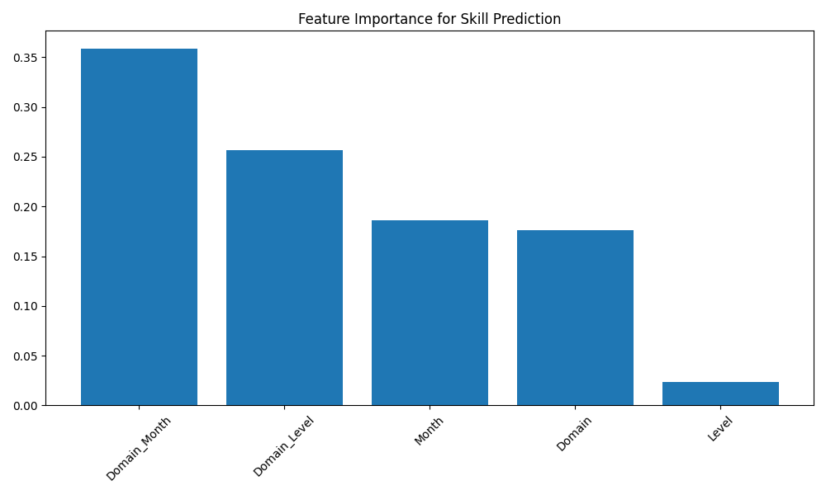

**Training Procedure:** We trained separate Random Forest models for predicting skills, primary resources, and secondary resources. This separation allows each model to specialize in its specific prediction task.

**Hyperparameter Optimization:** We employed RandomizedSearchCV with 3-fold cross-validation to identify optimal hyperparameters for each model. This process tested 25 different parameter combinations for each model, evaluating a total of 75 different configurations per prediction task.

**Ensemble Approach:** The Random Forest algorithm itself employs an ensemble of decision trees (ranging from 280-356 trees, depending on the specific model), which helps prevent overfitting and improves generalization.

The best-performing hyperparameter configurations varied across models:

* **Skill Model:** 280 estimators with a max depth of 34 and minimum samples split of 6
* **Resource 1 Model:** 356 estimators with a max depth of 39, "sqrt" max features, and minimum samples leaf of 3
* **Resource 2 Model:** 356 estimators with a max depth of 47, "sqrt" max features, and minimum samples leaf of 3

For the primary resource model, we found that the baseline configuration actually outperformed the tuned model, which is an interesting finding that highlights the importance of rigorous evaluation rather than assuming that more complex models will always perform better.

### **4.4 Prediction Pipeline**

Our prediction pipeline integrates the components described above into a coherent recommendation system:

1. **Input Processing:** The system takes user input regarding their technical domain, experience level, and desired learning timeline.
2. **Feature Transformation:** These inputs are transformed into the feature space used by our trained models.
3. **Multi-Model Prediction:** The system applies the appropriate Random Forest models to generate predictions for skills, primary resources, and secondary resources.
4. **Semantic Refinement:** The system uses semantic similarity calculations to ensure coherence across recommendations and to identify the most relevant project suggestions.
5. **Output Generation:** The final recommendations are formatted and presented to the user, including a set of prioritized skills, primary and secondary learning resources, and suggested projects.

This pipeline allows for real-time generation of personalized learning roadmaps that adapt to each user's specific circumstances

## **5. Results and Evaluation**

We employed multiple complementary metrics to thoroughly evaluate our system's performance, providing a comprehensive understanding of its effectiveness in generating relevant recommendations.

### **5.1 Sample UI**

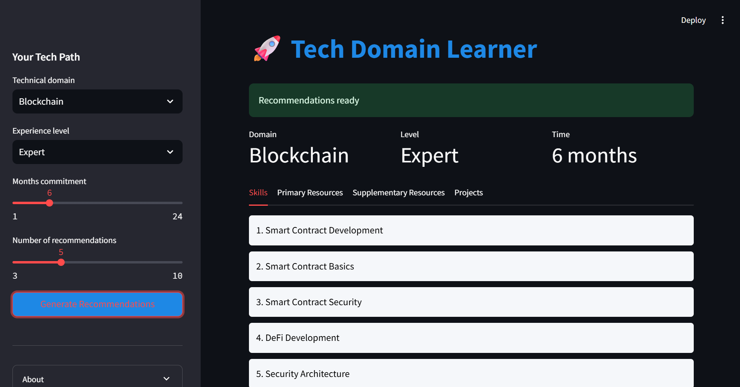

### **5.2 Top-5 Accuracy**

This metric represents the percentage of test cases where the correct recommendation appeared among the top 5 predictions made by the model. This is particularly relevant for recommendation systems, as users typically receive multiple suggestions rather than a single prediction.

Our results showed:

* **Skill Recommendations:** 75.43% accuracy (improved from 61.25% baseline)
* **Primary Resource Recommendations:** 59.25% accuracy
* **Secondary Resource Recommendations:** 65.00% accuracy (improved from 60.00% baseline)

These accuracy levels are particularly impressive given the specificity of our recommendations and the large number of possible options (189 unique skills and over 180 unique resources).

### **5.3 Mean Reciprocal Rank (MRR)**

MRR measures not just whether the correct item appears in the top recommendations, but also how highly it is ranked. An MRR of 1.0 would indicate that the correct recommendation is always the top prediction.

Our system achieved:

* **Skill Model MRR:** 0.7905
* **Primary Resource Model MRR:** 0.7419 (baseline model)
* **Secondary Resource Model MRR:** 0.6551

These MRR values indicate that when the system makes correct recommendations, they typically appear near the top of the suggestion list, enhancing the user experience by minimizing the need to sift through numerous options.

### **5.4 Semantic Similarity**

Beyond exact matches, we evaluated how semantically similar our recommendations were to the ideal answers. This accounts for cases where multiple resources might be equally valid (e.g., two different Python courses covering similar material).

The average maximum cosine similarity between predictions and ground truth was:

* **Skill Recommendations:** 0.8513
* **Primary Resources:** 0.9183 (baseline model)
* **Secondary Resources:** 0.7959

These high similarity scores indicate that even when our system doesn't predict the exact resource or skill from the test data, it typically recommends alternatives that are conceptually very similar.

### **5.5 Comparative Model Performance**

We compared our Random Forest approach with alternative algorithms:

|  |  |  |  |
| --- | --- | --- | --- |
| Model | RMSE | MAE | Top-5 Accuracy |
| KNN | 0.0345 | 0.0269 | 30.75% |
| Decision Tree | 0.0312 | 0.0240 | 34.50% |
| Random Forest | - | - | 79.83% (Skill) |

The substantial performance gap between the Random Forest ensemble and simpler models validates our architectural choices and hyperparameter optimization efforts.

### **5.6 Example Recommendations**

To illustrate the system's capabilities, here are sample recommendations for three different user profiles:

#### **Intermediate Machine Learning Professional (Month 4)**

**Recommended Skills:**

* Supervised Learning Advanced (similarity: 0.9653)
* Unsupervised Learning (similarity: 0.6167)
* Feature Engineering (similarity: 0.5575)

**Primary Resources:**

* StatQuest ML (similarity: 0.9990)
* Stanford ML Course (similarity: 0.5782)
* Business Statistics Course (similarity: 0.5200)

**Secondary Resources:**

* Hands-On ML with Scikit-Learn (similarity: 0.9660)
* Applied ML in Python (similarity: 0.7908)
* Hands-On Machine Learning (similarity: 0.7243)

#### **Beginning Web Developer (Month 2)**

**Recommended Skills:**

* HTML & CSS Basics (similarity: 0.7843)
* CSS Fundamentals (similarity: 0.7808)
* CSS Layouts & Responsive Design (similarity: 0.7378)

**Primary Resources:**

* The Odin Project (similarity: 0.7652)
* CS50 Web (similarity: 0.6927)
* CS50 Introduction to CS (similarity: 0.5839)

**Secondary Resources:**

* Responsive Web Design (similarity: 0.8109)
* HTML & CSS by Jon Duckett (similarity: 0.6522)
* CSS: The Definitive Guide (similarity: 0.5920)

#### **Advanced Data Analyst (Month 6)**

**Recommended Skills:**

* Advanced SQL & Data Warehousing (similarity: 0.8165)
* Data Visualization Basics (similarity: 0.7629)
* Data Warehousing (similarity: 0.7511)

**Primary Resources:**

* SQL for Data Warehousing (similarity: 0.9571)
* SQL for Data Analysis (similarity: 0.8132)
* Database Systems Concepts (similarity: 0.6784)

**Secondary Resources:**

* Tableau Fundamentals (similarity: 0.7989)
* Kimball's Data Warehouse Toolkit (similarity: 0.6985)
* Data Preparation for Analytics (similarity: 0.6717)

These examples demonstrate how the system tailor’s recommendations to specific combinations of domain, experience level, and timeline, providing highly relevant suggestions for each user's unique situation.

### **5.6 Analysis of Results**

Our evaluation reveals several important insights:

1. **High Contextual Relevance:** The system consistently recommends skills and resources that are contextually appropriate for the specified domain, experience level, and timeline.
2. **Resource-Skill Alignment:** The recommendations demonstrate good alignment between suggested skills and the resources that teach those skills, creating coherent learning paths.
3. **Timeline Sensitivity:** The system appropriately adjusts recommendations based on the user's timeline, suggesting more advanced skills for longer timeframes and more foundational skills for shorter ones.
4. **Semantic Understanding:** The high semantic similarity scores confirm that the system has developed a nuanced understanding of relationships between different skills and resources.
5. **Ensemble Advantage:** The superior performance of Random Forest compared to simpler models highlights the value of ensemble learning approaches for this problem domain.

Overall, these results validate the effectiveness of our approach and demonstrate that the Tech Domain Learner system provides valuable, personalized guidance for technical skill acquisition.

## **6. Advanced Approaches and Future Directions**

While our current ensemble learning approach has proven effective, we recognize the potential for further improvements through alternative embedding techniques and advanced methodologies.

### **6.1 Alternative Embedding Approaches**

Our current implementation relies on SentenceTransformer for creating semantic embeddings, but several alternative approaches could potentially enhance the system's performance or efficiency:

#### **6.1.1 Traditional NLP Approaches**

**Lemmatization + TF-IDF Vectorization** This more traditional approach combines linguistic processing with statistical vectorization:

* First, a lemmatizer reduces words to their base forms (e.g., "programming" → "program")
* Then TF-IDF (Term Frequency-Inverse Document Frequency) creates numerical vectors representing term importance
* This approach is computationally efficient but may miss deeper semantic relationships between concepts
* Implementation would be particularly straightforward using libraries like NLTK or spaCy for lemmatization and scikit-learn for TF-IDF vectorization.

**Word2Vec/GloVe + Averaging** A simpler embedding approach that could reduce computational demands:

* Use pre-trained word embeddings like Word2Vec or GloVe
* Create skill/resource vectors by averaging the word vectors of their constituent terms
* This approach loses some semantic nuance but offers significant efficiency gains
* Could be particularly valuable for deployment in resource-constrained environments

#### **6.1.2 Advanced Deep Learning Embeddings**

**Universal Sentence Encoder (USE)** Developed by Google, this model:

* Features dual encoder architecture with transformers for longer text
* Is specifically optimized for semantic similarity tasks
* Could serve as a direct substitute for SentenceTransformer with potentially different performance characteristics

**ELMo (Embeddings from Language Models)** A contextual embedding approach that:

* Creates word representations based on entire sentences
* Assigns different embeddings to the same word depending on its context
* Could provide richer representations of technical terms that have different meanings in different domains

**InferSent** Developed by Facebook Research:

* Uses supervised learning trained on natural language inference data
* Excels at capturing semantic relationships between sentences
* May perform particularly well for establishing meaningful similarity metrics between skills

#### **6.1.3 Lightweight Alternatives for Production**

**FastText** A more efficient embedding approach:

* Extends Word2Vec by representing words as bags of character n-grams
* Better handles specialized technical terminology and compound terms
* Could improve performance for domains with extensive specialized vocabulary

**LightGBM Embeddings** A gradient boosting approach to embedding:

* Uses tree-based models for dimensionality reduction
* Offers computational efficiency compared to neural approaches
* May work well for structured domains with clear categorical relationships

The optimal choice among these alternatives would depend on specific requirements around accuracy, computational resources, and scalability.

### **6.2 Deep Learning Approaches**

#### **6.2.1 Enhanced Contextual Understanding with Transformers**

Transformer-based models like BERT (Bidirectional Encoder Representations from Transformers) have revolutionized natural language processing by capturing deep contextual relationships between words and concepts. Applied to our recommendation system, such models could develop a more nuanced understanding of the relationships between domains, skills, and resources.

For example, a transformer model might recognize that "React Native" skills are more relevant to mobile development pathways than web development, even though both fall under the broader JavaScript ecosystem. This contextual awareness goes beyond what traditional machine learning algorithms can capture.

#### **6.2.2 Multi-Task Learning Architecture**

Instead of training separate models for skills, primary resources, and secondary resources, a deep learning approach could employ multi-task learning to simultaneously predict all three outputs. This architecture would leverage shared representations across tasks, potentially improving performance by allowing the model to identify subtle patterns that affect multiple recommendation types.

A multi-task architecture might recognize, for instance, that certain skill recommendations strongly imply particular resource types, creating a more coherent overall recommendation package.

#### **6.2.3 Direct Optimization for Similarity**

Our current approach evaluates semantic similarity as a post-hoc metric, but deep learning allows us to directly optimize for this objective during training. By employing Siamese networks or bi-encoder architectures with contrastive loss functions, we could train models that explicitly maximize the semantic similarity between predictions and ideal recommendations.

This approach would be particularly valuable given our finding that semantic similarity often matters more than exact matches in the recommendation context.

### **6.3 System Expansion Opportunities**

#### **6.3.1 User Feedback Integration**

Creating mechanisms to capture user feedback on recommendations would enable a continuous refinement loop:

* Users could rate suggestion relevance
* Feedback could be incorporated into model retraining
* System accuracy would improve over time through this iterative process

#### **6.3.2 Domain Expansion**

The current system covers 23 technical domains, but technology continues to evolve with emerging fields including:

* Quantum Computing
* AR/VR Development
* Blockchain Engineering
* Green Tech Development
* AI Ethics
* Biotechnology Informatics

Expanding our dataset to encompass these and other emerging domains would increase the system's utility and relevance.

### **6.4 Scalability Considerations**

As our dataset grows—incorporating more domains, resources, and learning pathways—deep learning models would likely demonstrate increasing advantages over traditional machine learning approaches. Transformer models in particular excel at learning from large datasets and can efficiently process the growing complexity of relationships between technical domains and skills.

Implementing a distributed computing architecture would support this scaling, allowing the system to process more data and serve more users simultaneously while maintaining response time performance.

## **7. Conclusion**

The Tech Domain Learner represents a significant advancement in personalized technical education guidance. By combining semantic embeddings with ensemble learning techniques, we've created a system capable of providing highly relevant skills, resources, and project recommendations tailored to individual users' domains, experience levels, and timelines.

### **7.1 Key Contributions**

This research has made several important contributions to the field of automated learning guidance:

1. **Novel Integration of Semantic Understanding with Recommendation Systems:** The combination of NLP-based semantic embeddings with Random Forest ensemble learning creates a powerful approach that captures both the meaning of resources and the patterns of successful learning trajectories.
2. **Data-Driven Learning Pathway Analysis:** Our methodology demonstrates how machine learning can identify effective learning sequences by analyzing patterns across successful learning paths.
3. **Multi-dimensional Personalization:** The system successfully adapts recommendations across multiple dimensions simultaneously (domain, experience level, and timeline), providing truly personalized guidance.
4. **Validation of Semantic Similarity as an Evaluation Metric:** Our results confirm that semantic similarity provides a valuable evaluation metric for recommendation systems in educational contexts, where conceptual relevance often matters more than exact matches.
5. **Creation of a Structured Technical Learning Dataset:** The curated dataset of 399 learning pathways across 23 domains represents a valuable resource for future research in this area.

### **7.2 Limitations**

While the Tech Domain Learner demonstrates strong performance, several limitations should be acknowledged:

1. **Dataset Size:** Despite careful curation, our dataset remains relatively small compared to commercial recommendation systems. Expanding the dataset would likely improve performance and coverage.
2. **Limited Temporal Analysis:** The current system doesn't account for how the relevance of skills and resources changes over time as technologies evolve.
3. **Static Recommendations:** The system provides one-time recommendations rather than adapting as a learner progresses through their chosen path.
4. **Resource Availability Assumptions:** The system assumes recommended resources are accessible to all users, which may not be true for paid courses or materials with geographic restrictions.
5. **Domain Coverage Gaps:** While the system covers 23 technical domains, the rapidly evolving technology landscape means some emerging fields may be underrepresented.

### **7.3 Future Work**

Based on our findings and the limitations identified, we've outlined several promising directions for future research:

1. **Deep Learning Integration:** Implementing the transformer-based and multi-task learning architectures described in Section 6 to further enhance recommendation quality.
2. **User Feedback Loop:** Creating mechanisms to capture user feedback on recommendations, which can be used to continuously refine and improve the model.
3. **Expanded Dataset:** Incorporating additional domains, particularly emerging fields like quantum computing, AR/VR development, and others that may be underrepresented in the current dataset.
4. **Temporal Analysis:** Developing models that can account for the evolution of skill importance over time, recognizing that the relevance of specific technologies changes as the industry evolves.
5. **Personalization Refinement:** Incorporating additional user characteristics such as learning style preferences, prior educational background, and career transition history to further personalize recommendations.
6. **Interactive Recommendation System:** Building an interactive system that can adjust recommendations based on user feedback and progress through their learning journey.

## **8. References**

[1] G. Louppe, *Understanding Random Forests: From Theory to Practice*, arXiv:1407.7502 [cs.LG], 2014. [Online]. Available:<https://arxiv.org/abs/1407.7502>

[2] A. Géron, *Hands-On Machine Learning with Scikit-Learn, Keras, and TensorFlow*, 3rd ed. Sebastopol, CA, USA: O’Reilly Media, 2022.

[3] F. Pedregosa *et al*., “Scikit-learn: Machine Learning in Python,” *J. Mach. Learn. Res.*, vol. 12, pp. 2825–2830, 2011. [Online]. Available:<http://www.jmlr.org/papers/v12/pedregosa11a.html>

[4] Scikit-learn Developers, “Feature transformations with ensembles of trees,” *Scikit-learn Documentation*, 2024. [Online]. Available:<https://scikit-learn.org/stable/auto_examples/ensemble/plot_feature_transformation.html>

[5] R. Tiwari, “Advanced Machine Learning with Scikit-learn: A Deep Dive,” *Medium*, 2024. [Online]. Available:<https://medium.com/@rahultiwari065/advanced-machine-learning-with-scikit-learn-a-deep-dive-81f5e89158e5>

[6] N. Kramer, “Scikit-Learn Pipelines: Build, Optimize, Explain,” *Daily.dev*, 2024. [Online]. Available:<https://daily.dev/blog/scikit-learn-pipelines-build-optimize-explain>

[7] Analytics Vidhya, “Build Your First Machine Learning Pipeline Using Scikit-Learn,” *Analytics Vidhya*, Jan. 2020. [Online]. Available:<https://www.analyticsvidhya.com/blog/2020/01/build-your-first-machine-learning-pipeline-using-scikit-learn/>